**Capstone Project: Create a Testing Framework for Sporty Shoes Website**

**Load Testing Sporty Shoes website using JMeter**

1. Setup or Configure Jmeter

**Development Environment:**

* Java 1.8
* JMeter

This guide has three subsections, namely:

3.1.1 Creating JMeter test

3.1.2 Pushing the code to GitHub repositories

**Step .1:** Creating a JMeter test

* Open JMeter
* Add new thread under the test plan
* 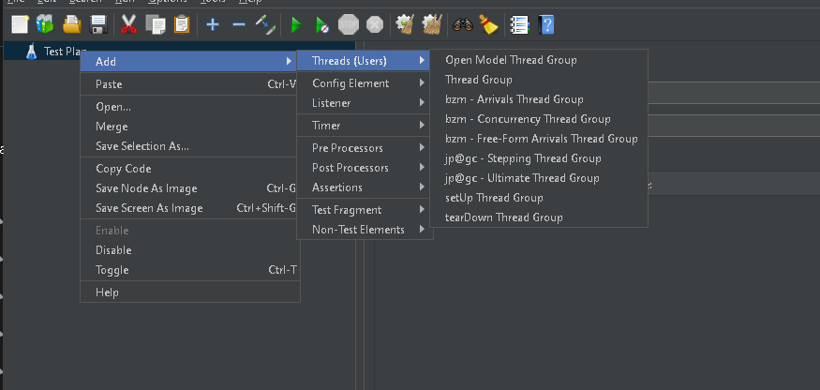
* Create two http samplers one for homepage other for product page
* 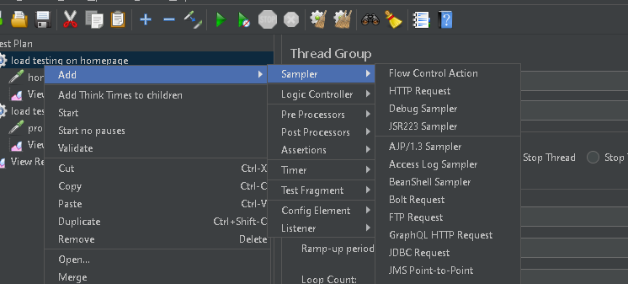
* Add listener to see the output
* 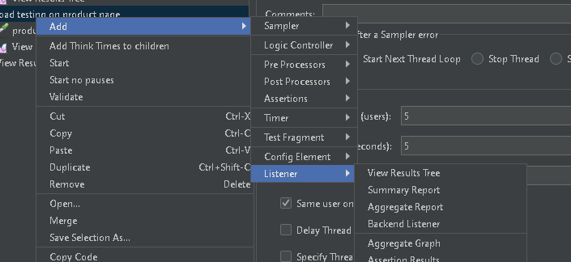
* Save the file
* Click on run

Push code to git repository

* Using git add .
* Git commit -m ”message”
* Git push -u <name> <link>